6.100L Recitation 9

Reminders
- MQ 9 on Monday 11/21

Review from the last 2 weeks…
Object Orientation Programming (OOP)
- Objects allow you to store data in python
- Everything in python is an object
- Class defines a type of object
  - so far in class we have seen the following built-in classes: int, float, string, list, tuples, dictionaries
- An object is an instance of its class
  - for example: 3, “hello”, [1,2,3] are all instances of a class
- Advantages of OOP:
  - Allows you to bundle data into packages
  - Reduces complexity of your code, making it easy to reuse code
  - Allows you to implement & test behaviour of each class separately

Classes
- a way to create your own data type using the built-in data types as building blocks
  - Real life examples: Elevator, employee, queue at store, stack of pancakes...
- attributes are data & procedures that belong to the class
  - Data attributes: objects that make up the class
  - Methods/procedural attributes: functions that only work with this class
- self:
  - Refers to the instance the method is called on
  - Always the 1st argument when defining a method
  - Not used outside the class definition
- Creating a class:
- Define class name
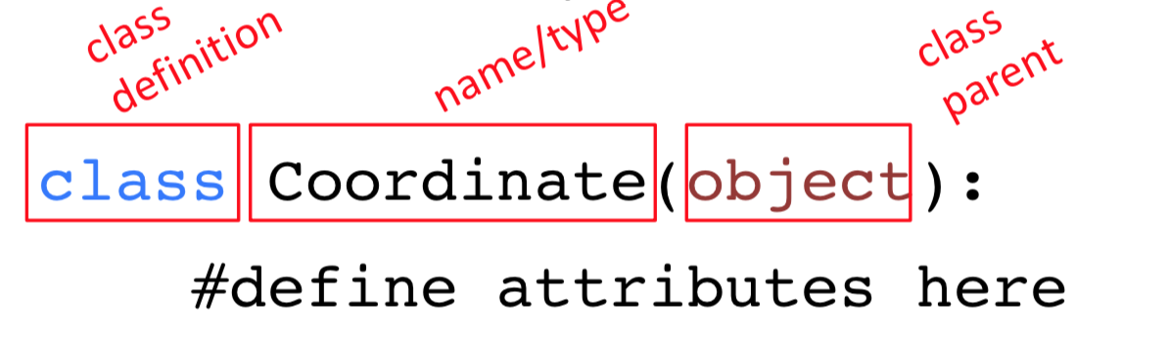
- Define class attributes
  - Define how to create an instance of a class using the __init__ method
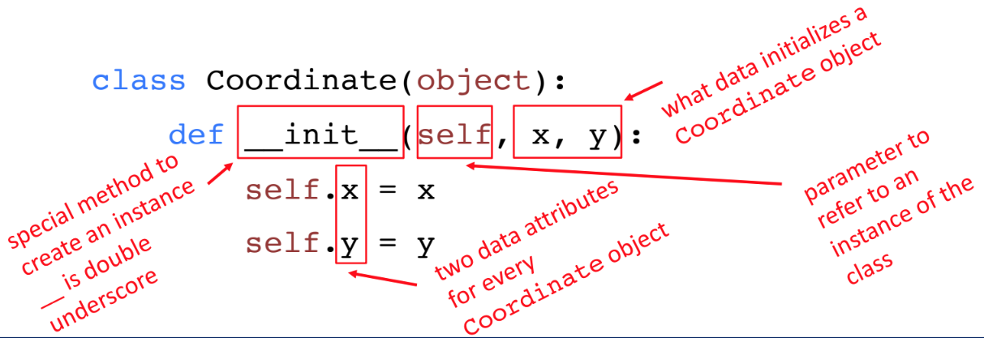
  - Define other methods, these do not need to start with __
These methods only work for this class.
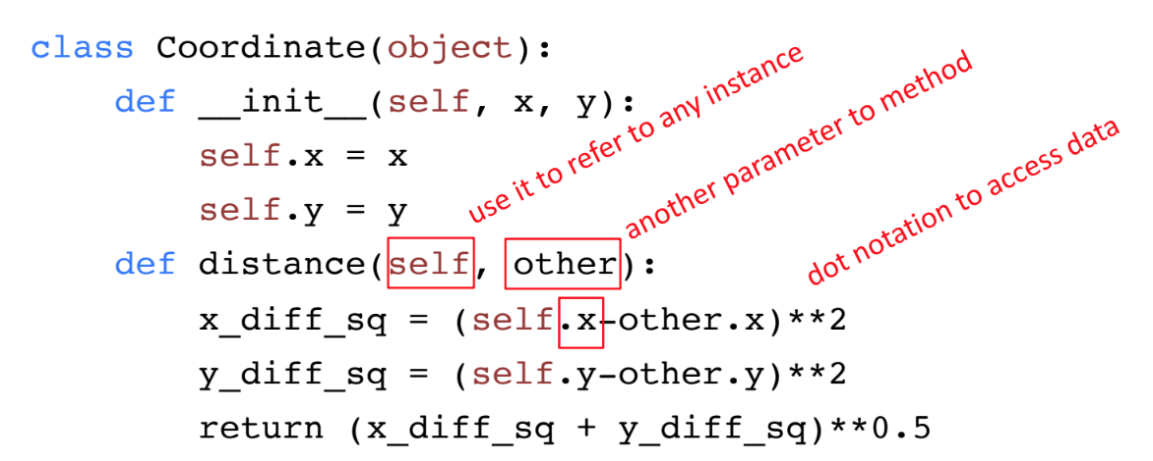
- Using a class:
- First create a new instance of the class
# Using the example Coordinate class above
  - c1 = Coordinate(1,1)
  - c2 = Coordinate(2,1)
- Carry out operations on the instances, using class methods
  - c1.distance(c2)

- In order to be able to call print on an instance of your class you need to define the __str__ function.
  - there are a few more special operators ( __len__, __eq__ etc… → look at lecture slides for details on these)
- You can use isinstance() to check if an instance is an object of a class.
- In general the class defines the representation and methods common across all instances of the class; whereas an object is a SPECIFIC instance of the class
- In general you want to keep your internal representation of your class hidden, to prevent adversarial attacks and bugs.
  - the internal representation refers to what is in your __init__ method
- class variables: shared across all members of a class
  - defined outside of the __init__ method

Getter and Setter Methods:
● Getter and setters should be used outside of classes to access data attributes.
● It’s better style to access attributes this way, makes code easier to maintain and
helps prevent bugs

Inheritance & Hierarchies:
Why use inheritance?
● Allows you to extend a class with new/different capabilities.
● Reuse code
● Commonalities are explicit in the parent class, differences explicit in the subclass

Structure & how it works:
● You create an inheritance relationship between two classes by defining what
goes into the parameter in the class definition.

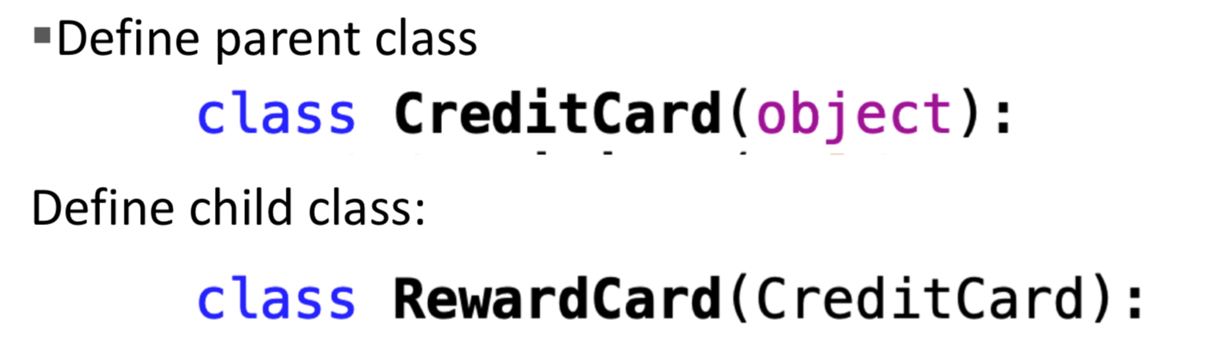

The child class inherits all the methods from the parent class.

● We can define new methods in the child class to extend behaviour
● We can redefine methods defined in the parent class to modify behaviour
● When you call a method on an instance of a class: the interpreter tries to find the
method at the level of a class and then checks the parent.
○ This means that if two methods with the same name are defined, the
method in the child class takes precedence.

MIT OpenCourseWare
https://ocw.mit.edu
6.100L Introduction to CS and Programming Using Python
Fall 2022
For information about citing these materials or our Terms of Use, visit: https://ocw.mit.edu/terms

